Terraform Deployment Guide for Db2 on AWS & IBM Cloud
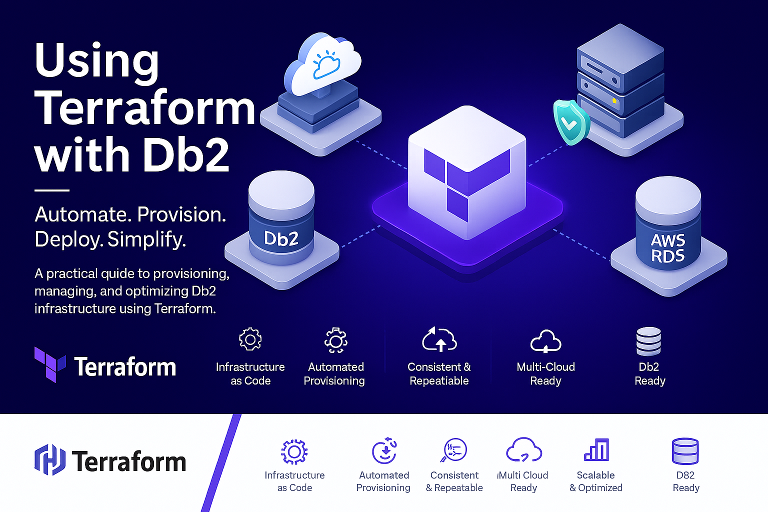

1. Purpose
This document provides enterprise-grade guidance for deploying and managing IBM Db2 resources using Terraform on IBM Cloud and AWS RDS. It is intended for customer enablement, and the standardization of production deployments.

2. IBM Cloud and AWS Db2 Terraform Providers – Overview
IBM Db2 is available as a fully managed database service on both IBM Cloud and AWS, with infrastructure provisioning supported through Terraform in each ecosystem. The IBM Cloud Db2 provider enables users to provision and manage Db2 instances as a native Database-as-a-Service (DBaaS) offering, where most of the underlying infrastructure complexity is abstracted and managed by IBM Cloud. Terraform is primarily used to define and configure the Db2 service instance in a simplified, resource-driven manner.
In contrast, AWS provides Db2 through Amazon RDS for Db2, where Terraform is used to orchestrate not only the database instance but also several supporting components such as networking, security configurations, encryption, and licensing management. This results in a more infrastructure-oriented deployment approach compared to the service-abstraction model on IBM Cloud.
For more detailed reference, the official provider and deployment documentation can be found below:
- IBM Cloud Terraform Db2 Provider:
https://registry.terraform.io/providers/IBM-Cloud/ibm/latest/docs/resources/db2

- AWS RDS for Db2 Automation with Terraform:
https://aws.amazon.com/blogs/database/automate-the-deployment-of-amazon-rds-for-db2-instances-with-terraform/

3. Scope
This guide covers:
- Installation and configuration of Terraform
- IBM Cloud access and authentication
- Deployment of Db2 on IBM cloud and AWS with detailed step-by-step guidance

4. Prerequisites
Ensure the following prerequisites are met before proceeding:

4.1 Required Tools
- Terraform (latest stable version recommended)
- Command-line interface (CLI) access
- Git

4.2 Access Requirements
IBM Cloud
- Active IBM Cloud account
- Appropriate IAM permissions to provision Db2 resources
- IBM Cloud API Key

AWS
- Active AWS account
- An IAM user with necessary permissions to provision and manage AWS resources
- AWS access key and secret key Access
- Configured AWS CLI or IAM role with required permissions

4.3 Skills and Knowledge
- Basic understanding of Infrastructure as Code (IaC) concepts
- Familiarity with Terraform workflow (init, plan, and apply)
- General knowledge of cloud networking and database concepts
- Basic understanding of IBM Cloud and AWS services and resource management

5. Environment Setup

5.1 Install Terraform
Terraform installation steps can be found here:
https://developer.hashicorp.com/terraform/install

5.2 Install Git
Git installation steps can be found here: https://git-scm.com/book/en/v2/Getting-Started-Installing-Git

5.3 Install AWS CLI (required only for AWS deployments and not for IBM cloud)
AWS CLI installation steps can be found here:
https://docs.aws.amazon.com/cli/latest/userguide/getting-started-install.html

6. DB2 Configuration on IBM Cloud

6.1 Access IBM Cloud
Access the IBM Cloud console: https://cloud.ibm.com/login

6.2 Generate API Key
Once logged in, then create an API key for the deployment
Create an API key for authentication:https://test.cloud.ibm.com/iam/apikeys
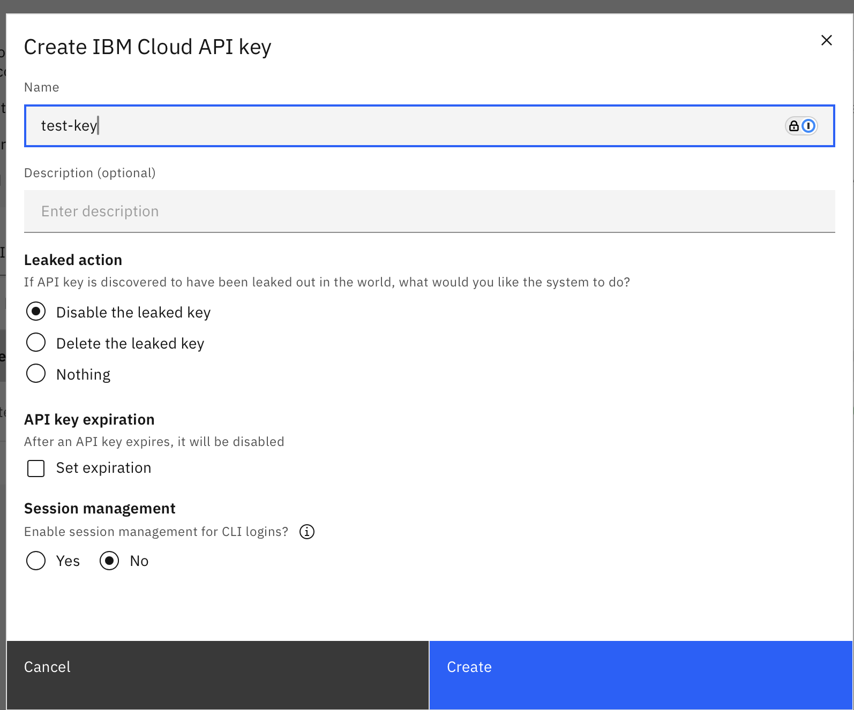
Note: Store the API key securely. Do not expose it in code repositories.

6.3 Deployment Procedure

6.3.1 Terraform Files Overview
- main.tf – The primary configuration file that defines the infrastructure resources and settings for deployment.
- variables.tf – The file that defines all the variables.
- versions.tf – The file used to specify the required Terraform and provider versions for a project.
- terraform.tfvars – You can furnish here the region, api key and resource group

6.3.2 Environment setup
1 mkdir db2-deployment
2 cd db2-deployment

Download all required Terraform files
1 curl -O https://raw.githubusercontent.com/IBM-Cloud/terraform-provider-ibm/master/examples/ibm-db2/main.tf
2 curl -O https://raw.githubusercontent.com/IBM-Cloud/terraform-provider-ibm/master/examples/ibm-db2/variables.tf
3 curl -O https://raw.githubusercontent.com/IBM-Cloud/terraform-provider-ibm/master/examples/ibm-db2/provider.tf
4 curl -O https://raw.githubusercontent.com/IBM-Cloud/terraform-provider-ibm/master/examples/ibm-db2/versions.tf

Create terraform.tfvars with your credentials:
cat > terraform.tfvars << EOF
ibmcloud_api_key = "YOUR_IBM_CLOUD_API_KEY"
region = "us-south"
resource_group = "Default"
EOF

Replace the API_KEY with the generated one from the IBM cloud console

6.3.3 Initialize Terraform
1 terraform init
This step downloads provider plugins and initializes the working directory.

6.3.4 Validate Configuration
1 terraform validate

6.3.5 Review Execution Plan
1 terraform plan
- Verifies configuration changes
- Displays resources to be created, modified, or deleted

6.3.6 Apply Configuration
1 terraform apply
- Provisions Db2 resources in IBM Cloud
- Requires confirmation before execution

6.4. Post-Deployment Validation
- Verify resource creation in IBM Cloud console
- Check Db2 instance status and connectivity
- Validate network and security configurations

6.5. Resource Lifecycle Management

6.5.1 Update Resources
Modify Terraform configuration and re-run it if any changes are made:
1 terraform plan
2 terraform apply

6.5.2 Destroy Resources
1 terraform destroy

7. DB2 Configuration on AWS RDS

7.1 Access IBM Cloud
Access the IBM Cloud console: https://signin.aws.amazon.com/

7.2 Generate API Key
Once logged in, navigate to the IAM console, select the respective user, and create access key and secret key for that user
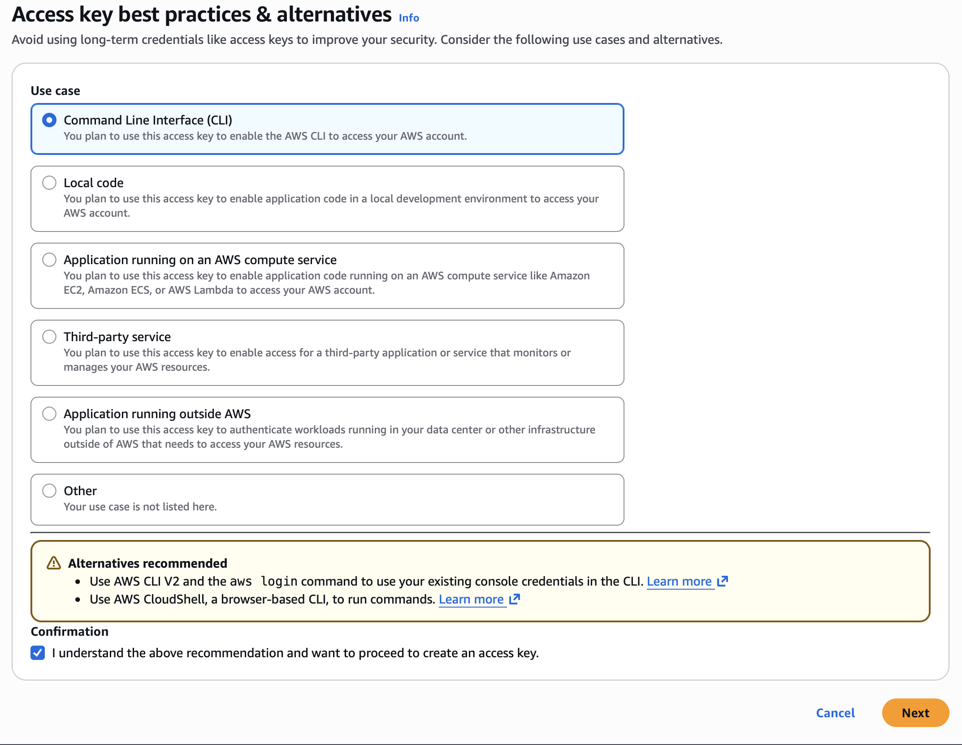
Note: Store the keys securely. Do not expose it in code repositories.

7.3 Deployment Procedure
7.3.1 AWS configure
1 aws configure
You'll be prompted for:
AWS Access Key ID [None]: PASTE_YOUR_ACCESS_KEY_ID_HERE
AWS Secret Access Key [None]: PASTE_YOUR_SECRET_ACCESS_KEY_HERE
Default region name [None]: us-east-2
Default output format [None]: json

7.3.2 Terraform Files Overview

- main.tf – The primary configuration file that defines the infrastructure resources and settings for deployment.
- variables.tf – The file that defines all the variables.
- rdsdb2test.tfvars – The file that provides values for variables specific to an environment. For instance, it includes settings for deploying an RDS for the Db2 test environment. Organizations often manage multiple environments, such as development, staging, and production, each with its own .tfvars file. This practice helps maintain organized and manageable configurations across different environments. We need to furnish the ibm_customer_id, ibm_site_id, available vpc, subnet, and mail id details in this file.
- rdsdb2prod.tfvars – The sample file for Production environment.
- versions.tf – The file used to specify the required Terraform and provider versions for a project.
- outputs.tf – The Terraform configuration file used to define output values from the Terraform configuration, typically for use by other configurations or for informational purposes.

7.3.3 Environment setup
1 mkdir rds-db2-deployment
2 cd rds-db2-deployment

Download all required Terraform files

1 curl -O https://raw.githubusercontent.com/aws-samples/amazon-rds-db2-terraform/main/main.tf
2 curl -O https://raw.githubusercontent.com/aws-samples/amazon-rds-db2-terraform/main/variables.tf
3 curl -O https://raw.githubusercontent.com/aws-samples/amazon-rds-db2-terraform/main/outputs.tf
4 curl -O https://raw.githubusercontent.com/aws-samples/amazon-rds-db2-terraform/main/version.tf
5 curl -O https://raw.githubusercontent.com/aws-samples/amazon-rds-db2-terraform/main/rdsdb2test.tfvars

Modify rdsdb2test.tfvars with your credentials:

Required Updates:
- ibm_customer_id: Your IBM Customer ID (for BYOL)
- ibm_site_id: Your IBM Site ID (for BYOL)
- subnet_ids: Your VPC subnet IDs (e.g., ["subnet-abc123", "subnet-def456"])
- vpc_id: Your VPC ID (e.g., "vpc-abc12345")
- vpc_cidr: Your VPC CIDR block
- s3_bucket_name: Your S3 bucket name (must exist)
- alert_email_address: Your email for alerts

7.3.4 Initialize Terraform
1 terraform init

7.3.5 Validate Configuration
1 terraform validate

7.3.6 Review Execution Plan
1 terraform plan
According to this plan, 20 resources will be created

7.3.7 Apply Configuration
1 terraform apply

7.4. Post-Deployment Validation
- Verify resource creation in AWS console
- Check Db2 instance status and connectivity
- Validate network and security configurations

7.5. Resource Lifecycle Management

7.5.1 Update Resources
Modify Terraform configuration and re-run it if any changes are made:
1 terraform plan
2 terraform apply

7.5.2 Destroy Resources
1 terraform destroy

8. Conclusion
This document demonstrated the deployment of IBM Db2 environments on AWS and IBM Cloud using Terraform to enable a consistent, automated, and scalable infrastructure provisioning process. By leveraging Infrastructure as Code (IaC), the deployment approach reduces manual effort, improves deployment reliability, and ensures standardized environment configuration across cloud platforms.
This deployment framework can serve as a foundation for efficiently managing Db2 infrastructure across hybrid and multi-cloud environments while supporting operational consistency and scalability.

9. About the Author

Jobi A I is a Software Developer at IBM India Software Lab, Kochi, passionate about building scalable cloud-native and DevOps solutions. He specializes in AWS, Kubernetes, OpenShift, Terraform, Ansible, Jenkins, Python, and Go, with a strong focus on automation, infrastructure engineering, and modern CI/CD practices. As a RHEL Certified professional, Jobi enjoys simplifying complex systems through efficient and reliable engineering.

📩 jobiai@ibm.com

